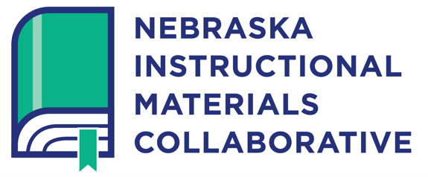
Because materials matter for all Nebraska students.

Dear Families,

All students deserve the education they need to achieve their full potential. This means that classroom instruction must align to, and support, the learning expectations provided in Nebraska’s content area standards. Approved by the state, content area standards describe what students should know and be able to do in grades K-12. A key part of standards-aligned instruction are the instructional materials used to support student learning.

[School District] recently began the process of selecting new instructional materials for [Content Area] in grades [Grade Levels]. A major element of this process is to determine how well the materials meet state standards and how well the materials meet our district’s and community’s educational priorities. The advice of parents and community members is essential in the process of selecting instructional materials and resources. We are requesting your attendance at [Location] on [Month, Day, Year] at [Time] to gain important input and feedback from you on the instructional materials our school will use.

The outcomes for the meeting are to:
- Review the district’s goals for high-quality, standards-aligned instructional materials
- Hear your recommendations for instructional materials to support student learning
- Learn how instructional materials can help meet the personal needs of students

To assist us in these efforts, we will use the Nebraska Instructional Materials Collaborative (NIMC) developed by the Nebraska Department of Education. This tool highlights high-quality, standards-aligned instructional materials and provides resources needed to use the materials effectively so that Nebraska teachers are better equipped to support all students. We invite you to check out http://www.nematerialsmatter.org/ to learn more about this valuable resource.

We appreciate your help with this important process. We look forward to seeing you on [Date].

Name
Title
District

